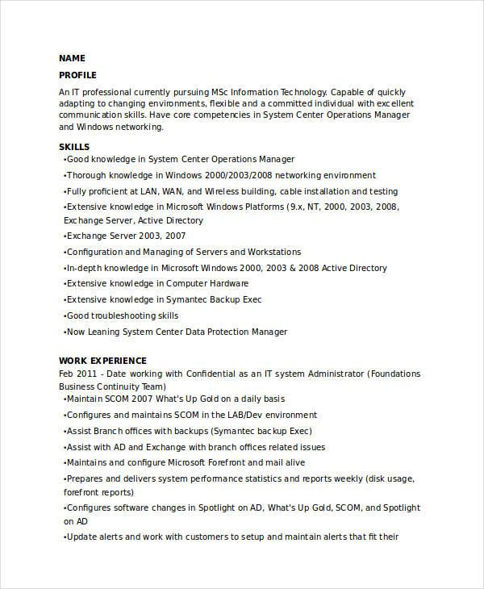
NAME PROFILE
An IT professional currently pursuing MSc Information Technology. Capable of quickly adapting to changing environments, flexible and a committed individual with excellent communication skills. Have core competencies in System Center Operations Manager and Windows networking.
SKILLS
•Good knowledge in System Center Operations Manager
•Thorough knowledge in Windows 2000/2003/2008 networking environment
•Fully proficient at LAN, WAN, and Wireless building, cable installation and testing •Extensive knowledge in Microsoft Windows Platforms (9.x, NT, 2000, 2003, 2008, Exchange Server, Active Directory
•Exchange Server 2003, 2007
•Configuration and Managing of Servers and Workstations
•In-depth knowledge in Microsoft Windows 2000, 2003 & 2008 Active Directory
•Extensive knowledge in Computer Hardware
•Extensive knowledge in Symantec Backup Exec
•Good troubleshooting skills
•Now Leaning System Center Data Protection Manager
WORK EXPERIENCE
Feb 2011 - Date working with Confidential as an IT system Administrator (Foundations Business Continuity Team)
•Maintain SCOM 2007 What's Up Gold on a daily basis
•Configures and maintains SCOM in the LAB/Dev environment
•Assist Branch offices with backups (Symantec backup Exec)
•Assist with AD and Exchange with branch offices related issues
•Maintains and configure Microsoft Forefront and mail alive
•Prepares and delivers system performance statistics and reports weekly (disk usage, forefront reports)
•Configures software changes in Spotlight on AD, What's Up Gold, SCOM, and Spotlight on AD
⚫Update alerts and work with customers to setup and maintain alerts that fit their

